**Image and Video Processing**

EEE412

Lab 2 - report

Name: Cong Yin

ID Number: 1715471

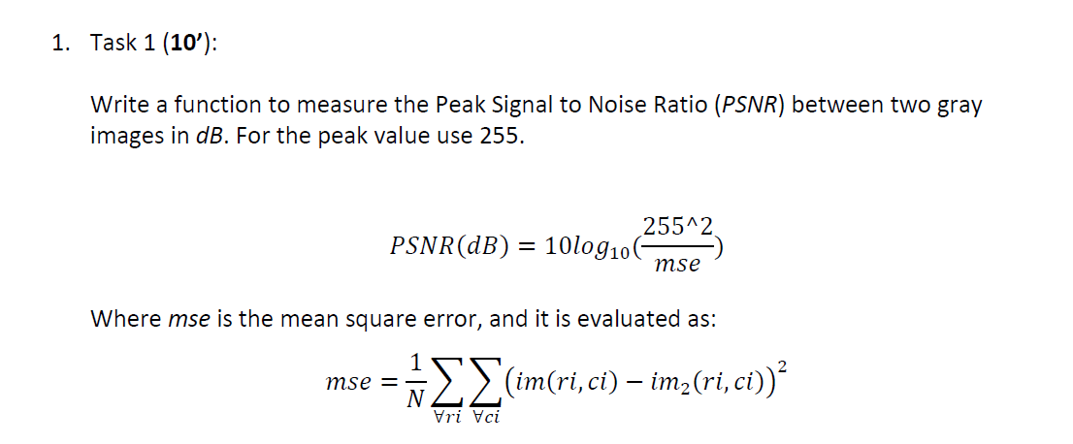

1.

function psnr = calculate_psnr(im1, im2)

image_o = double(im1);

image_m = double(im2);

[h, w] = size(image_m);

mse = sum(sum((image_o-image_m).^2))/(h*w);%mean square error

psnr = 10* log(255^2/mse)/log(10);%peak signal to noise ratio

end

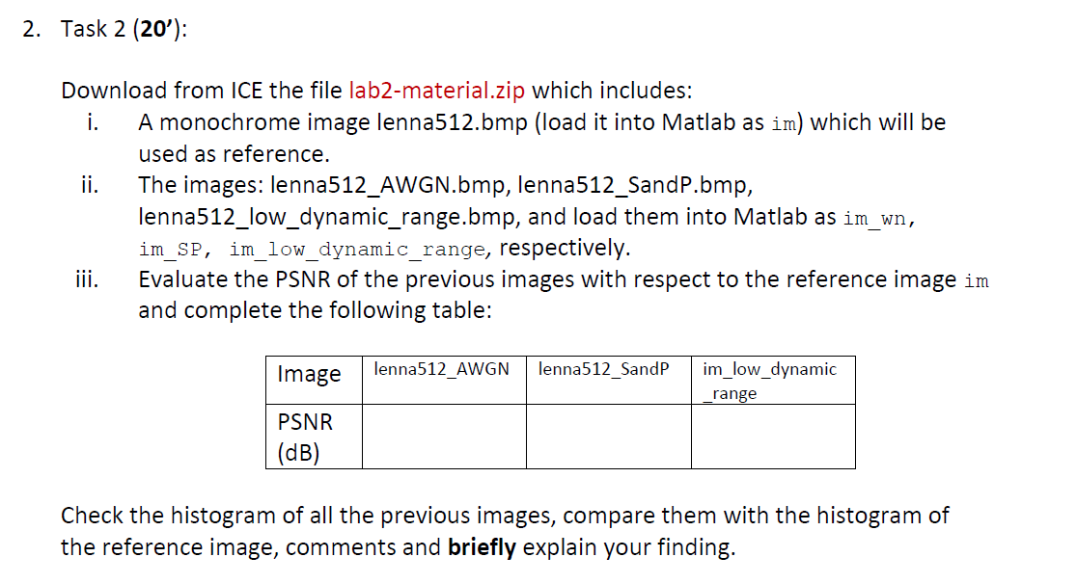

2.

img1=imread('lenna512.bmp');

img2=imread('lenna512_AWGN.bmp');

img3=imread('lenna512_SandP.bmp');

img4=imread('lenna512_low_dynamic_range.bmp');

psnr = calculate_psnr(img1, img2) %calculate the psnr by solution of Q1

psnr = calculate_psnr(img1, img3) %calculate the psnr by solution of Q1

psnr = calculate_psnr(img1, img4) %calculate the psnr by solution of Q1

subplot(2,2,1)

imshow(img1)

subplot(2,2,2)

imhist(img1)

axis([-10 300 0 5000])

subplot(2,2,3)

imshow(img2)

subplot(2,2,4)

imhist(img2)

axis([-10 300 0 5000])

psnr =

28.1069

psnr =

19.4781

psnr =

23.9912

|  |  |  |  |
| --- | --- | --- | --- |
| Image | lenna512_AWGN | lenna512_SandP | im_low_dynamic _range |
| PSNR(dB) | 28.1069 | 19.4781 | 23.9912 |

Run the above code, we can get the following functional image.

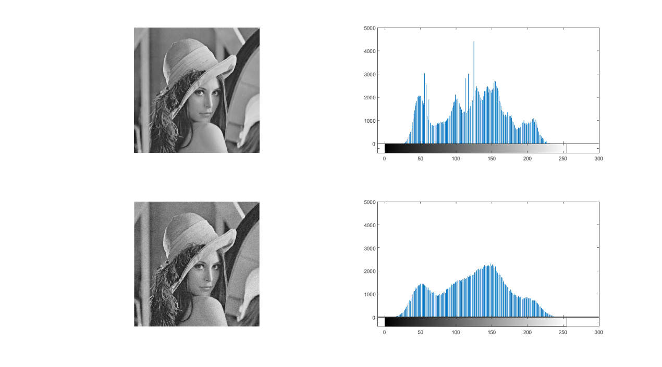

**Figure 1-1 lenna512_AWGN**

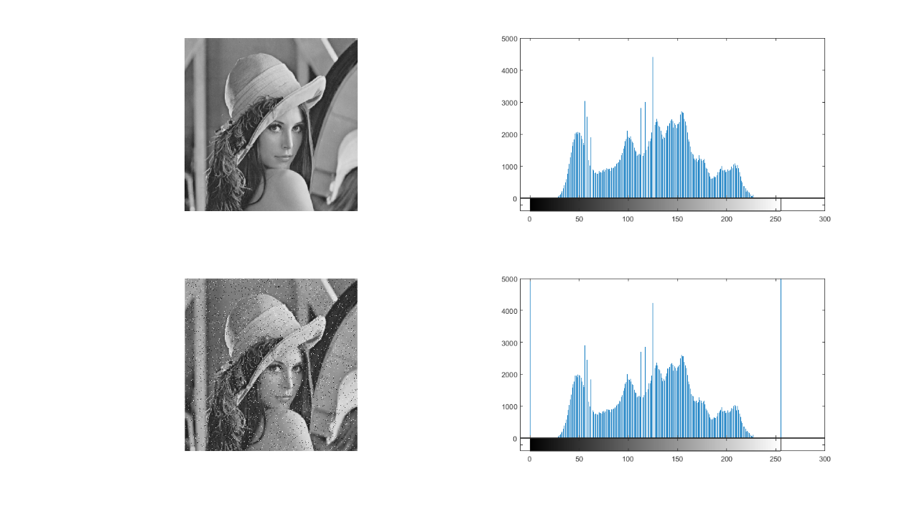

**Figure 1-2 lenna512_ SandP**

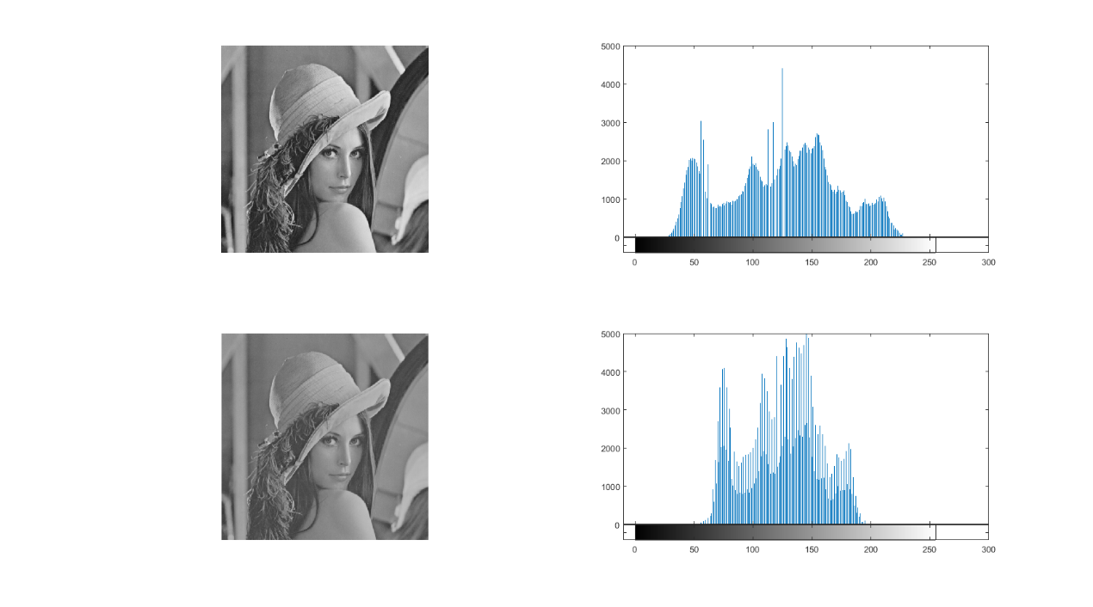

**Figure 1-3 im_low_dynamic _range**

Peak Signal to Noise Ratio is objective criterion to evaluate the image, the function is PSNR=10*log10((2^n-1)^2/MSE). The value of PSNR is smaller means distortion is fewer. So using bilinear interpolation is better.

The grey level histogram is a function for grey level, from the first figure shows many pixels was reduced. From the first figure shows that almost nothing has changed with the original but display two vertical line in the zero and from 200 to 250. From the third figure shows the ‘im_low_dynamic _range’ significantly reduced the pixel (from 0 to 50 and 200 to 250 gray level).

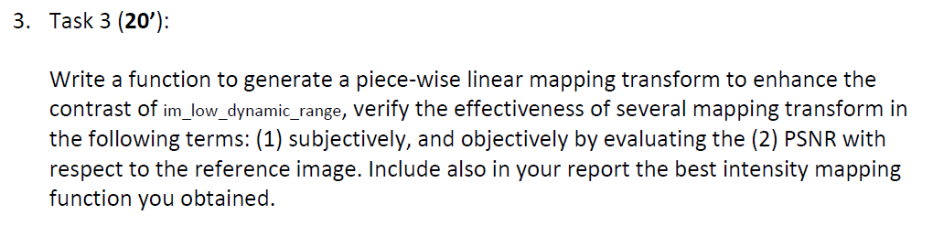

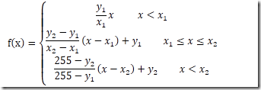

**Figure 3-1 The functional form of piece-wise linear mapping transform**

function im2 = enhance (im1,x1,y1,x2,y2)

[m,n]=size(im1);

im2=double(im1);

r1=y1/x1; %calculate the slope r1

r2=(y2-y1)/(x2-x1); %calculate the slope r2

r3=(255-y2)/(255-x2); %calculate the slope r3

for i=1:m

for j=1:n

f=im2(i,j);

y(i,j)=0;

if(f<x1)

y(i,j)=r1*f;

elseif(f>=x1)&(f<=x2)

y(i,j)=r2*(f-x1)+y1;

elseif(f>=x2)

y(i,j)=r3*(f-x2)+y2;

end

end

end

end

im1=imread('lenna512_low_dynamic_range.bmp');

original=imread('lenna512.bmp)

figure,imshow(im1)

x0=0;y0=0;

x1=20;y1=10;

x2=180;y2=230;

figure,plot([x0,x1,x2],[y0,y1,y2])

axis tight,xlabel('f'),ylabel('g')

title('intensity transformation')

im2 = enhance(im1,x1,y1,x2,y2)

figure,imshow(mat2gray(im2))

psnr = calculate_psnr(original, im2)

psnr=

23.9912

Run the above code, we can get the following functional image.

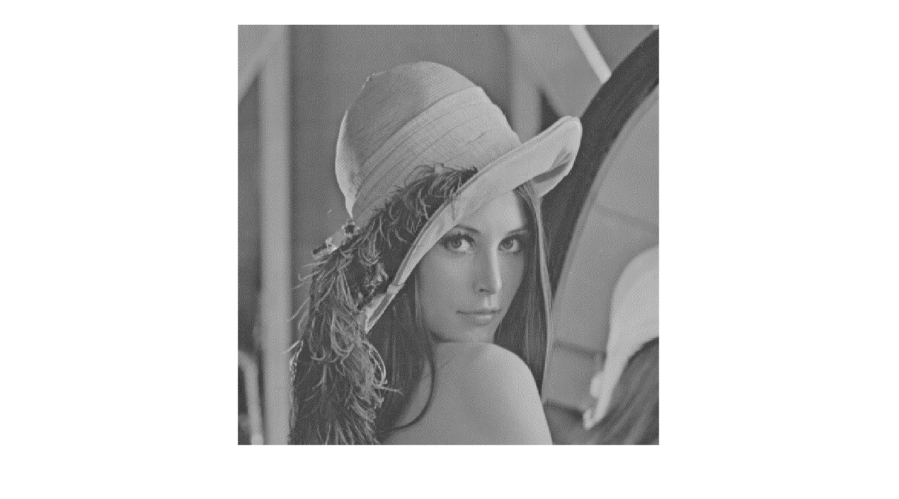

**Figure 3-2 im_low_dynamic _range**

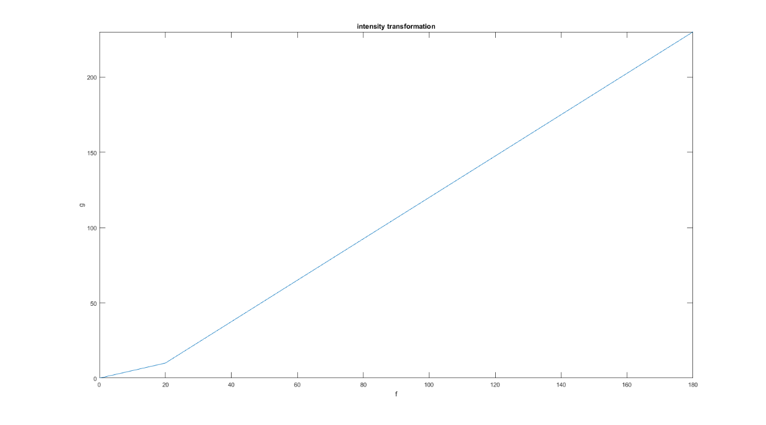

**Figure 3-3 intensity transformation**

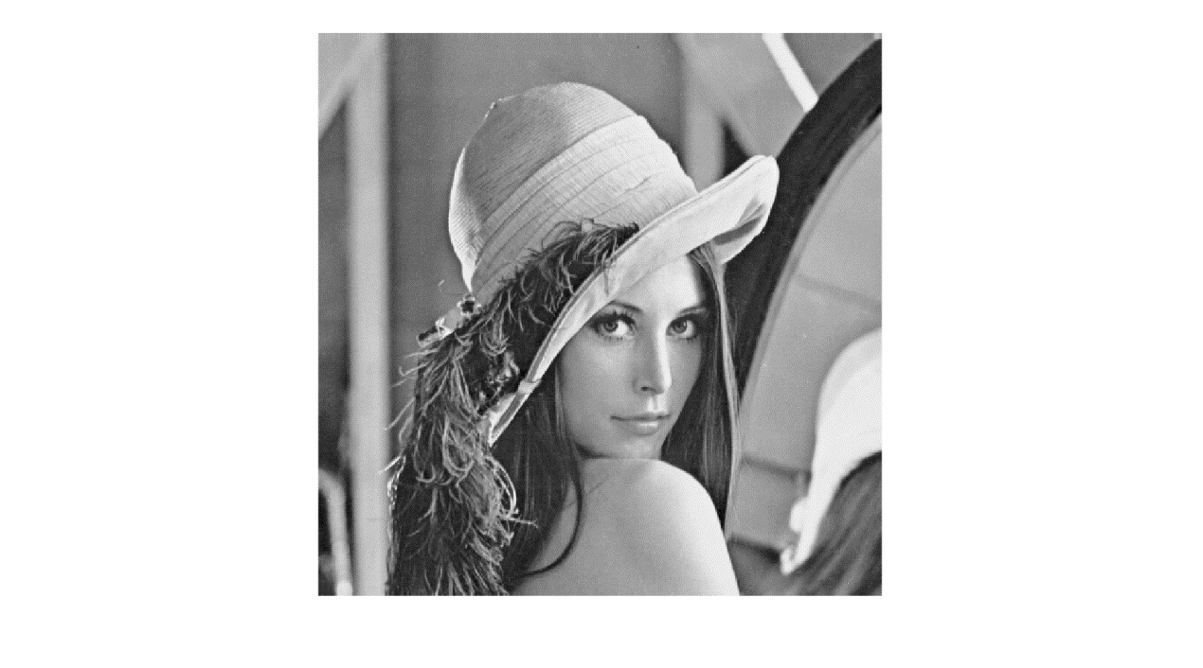

**Figure 3-4 Output image according to the piece-wise linear mapping transform**

The piecewise points of piece-wise linear mapping transform is according to the gray scale, that can enhance the contrast for each part in the original picture. In other words, it can enhance some gray scale areas which needed to enhance and weaken some gray scale areas which needed to weaken.

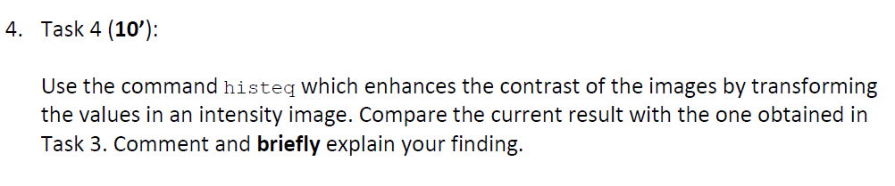

im1 = imread('lenna512_low_dynamic_range.bmp');

original=imread('lenna512.bmp)

im2 = histeq(im1);

imshow(im1)

figure, imshow(im2)

psnr = calculate_psnr(original, im2)

psnr =

19.0767

Run the above code, we can get the following functional image.

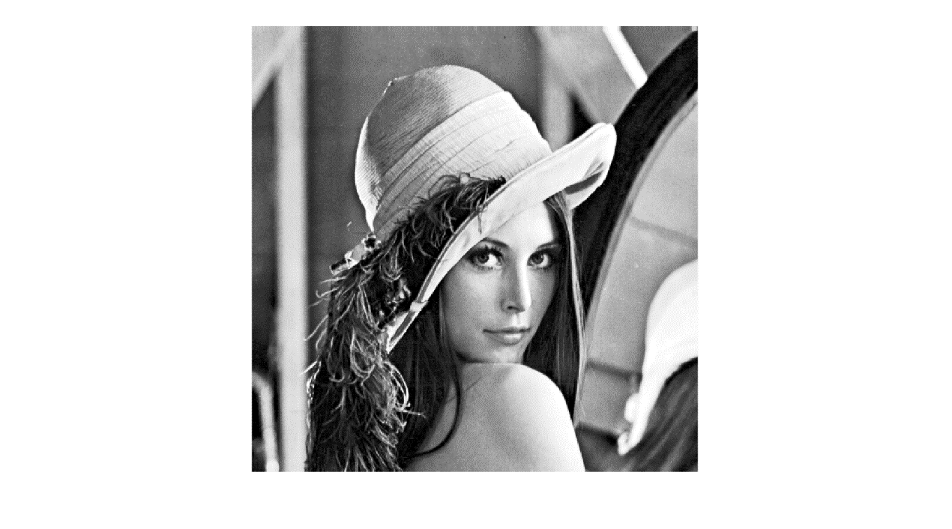

**Figure 4-1 Output image according to ‘histeq’**

The histogram equalization can change each gray value according to a transformation formula

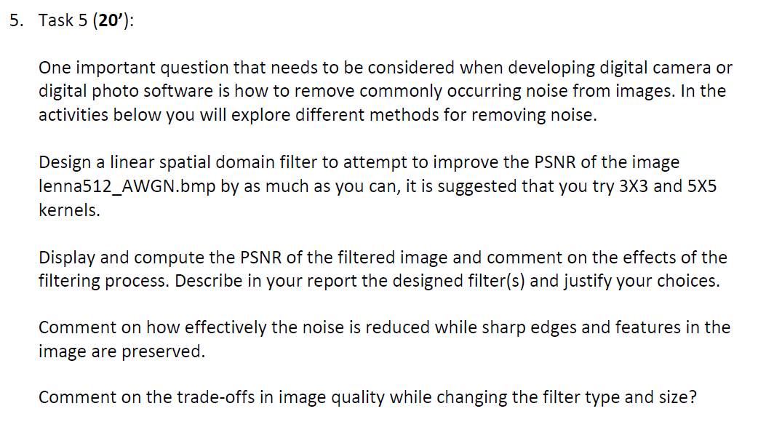

im1=imread('lenna512.bmp');

im2=imread('lenna512_AWGN.bmp');

filter_a=[1,2,1;2,1,2;1,2,1]; %the size of the filter is 3*3

filter_a=filter_a./13;

filter_b=[2,5,2;5,2,5;2,5,2]; %the size of the filter is 3*3

filter_b=filter_b./30;

filter_c=[2,2,2,2,2;2,5,5,5,2;2,5,2,5,2;2,5,5,5,2;2,2,2,2,2;]; %the size of the filter is 5*5

filter_c=filter_c./74;

im_filtera=imfilter(im2,filter_a);

im_filterb=imfilter(im2,filter_b);

im_filterc=imfilter(im2,filter_c);

psnra=calculate_psnr(im1,im_filtera);

psnrb=calculate_psnr(im1,im_filterb);

psnrc=calculate_psnr(im1,im_filterc);

figure;

subplot(2,2,1),imshow(im1),title('Original');

subplot(2,2,2),imshow(im_filtera),title('First Filter');

subplot(2,2,3),imshow(im_filterb),title('Second Filter');

subplot(2,2,4),imshow(im_filterc),title('Third Filter');

psnra=

31.0711

psnrb=

31.0720

psnrc=

28.9323

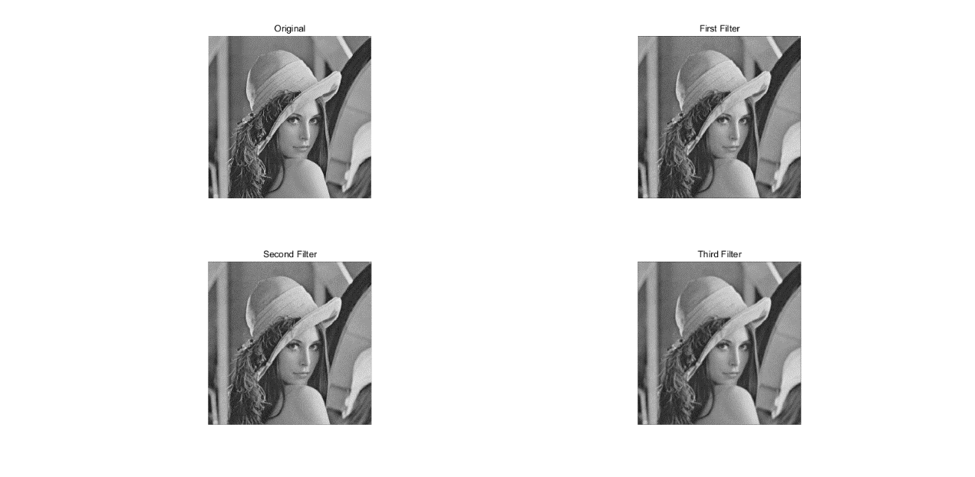

Figure5-1 the different size of the average filters

Gauss noise means every pixel in the image makes random noise from the original gray value according to the Gauss distribution, so the average filter is more appropriate. The two filters by ‘3*3’ can get the close psnr value, but the quality of third filter by ‘5*5’ is not better than ‘3*3’. It is means that the big size cannot make the quality of the image feel better.

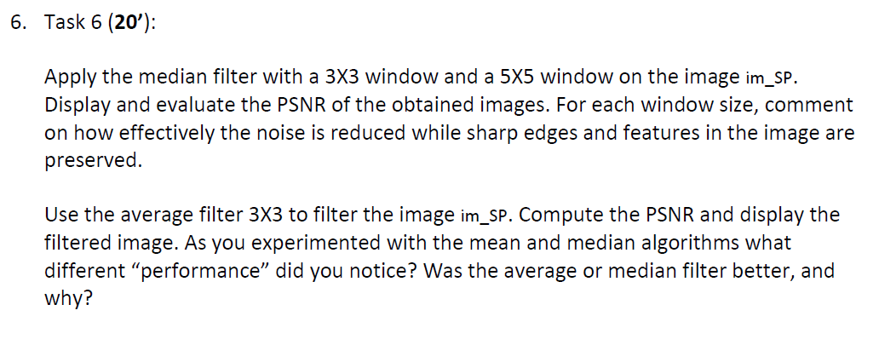

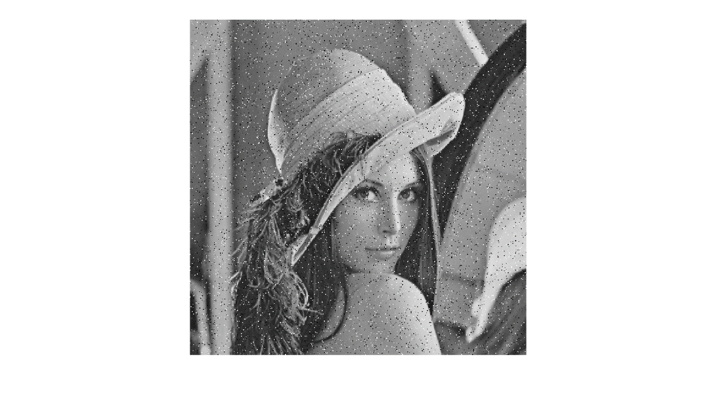

**Figure 6-1 im_sp**

Median filter

im1=imread('lenna512_SandP.bmp');

original=imread('lenna512.bmp)

figure;

imshow(im1);

im2=medfilt2(im1,[3 3]);

figure;

imshow(im2);

psnr = calculate_psnr(original, im2)

psnr =

34.7099

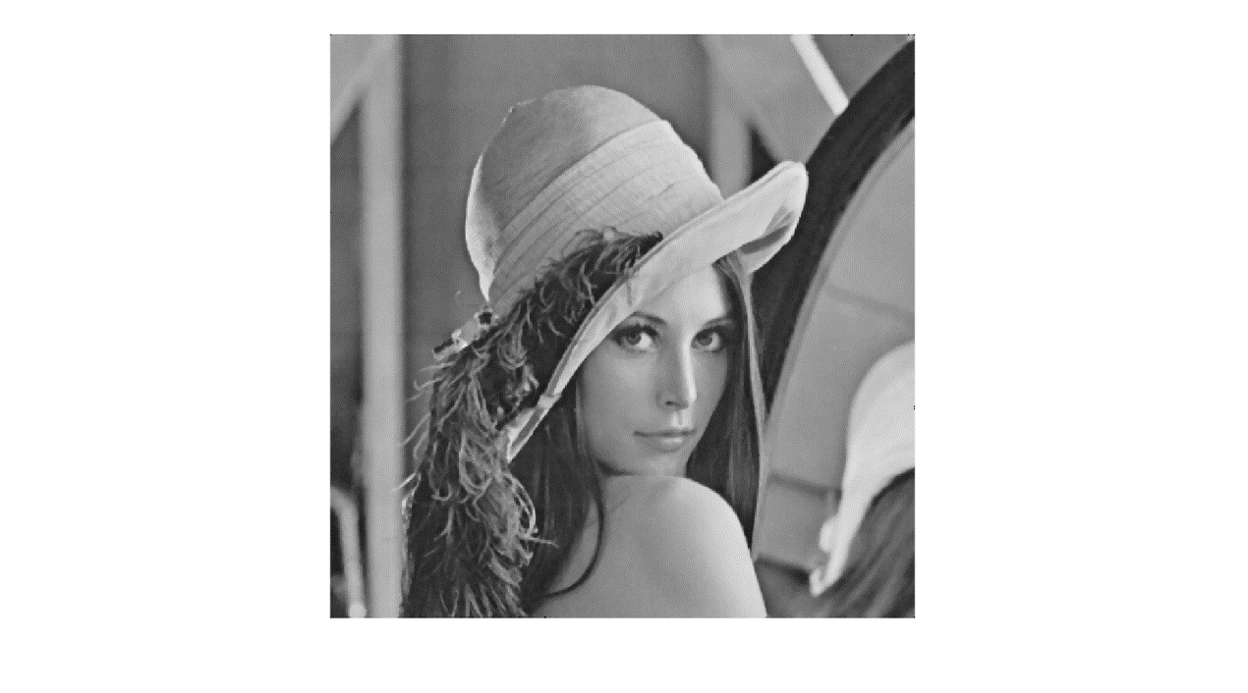

**Figure 6-2 Output image according to average filter**

Average filter

clear all;

im1=imread('lenna512_SandP.bmp');

original=imread('lenna512.bmp)

imshow(im1);

im2=filter2(fspecial('average',3),im1)/255;

figure;

imshow(im2);

psnr = calculate_psnr(original, im2)

psnr =

5.6929

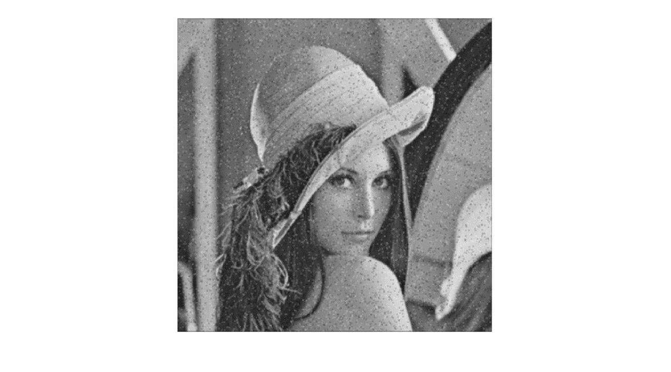

**Figure 6-3 Output image according to median filter**

According to the Figure 6-2 and Figure 6-3 that shows the median filtering are more suits for the noise of the pepper salt. Because the noise of the pepper salt is a kind of noise which value is get the 0 or 255 and the probability of occurrence is very low, the median filtering is remove the median, so that cannot be influenced by the value of noise (0 or 255), but average filter is an average value that will influenced by the value of noise (0 or 255) and it is a serious influence. So the result is not satisfactory.